Task 7
In order to measure execution time, profiling is enabled:
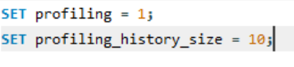
Query before optimization:
Purpose: Traveller-facing package search, returns all active packages with their average rating, agency name, cheapest option price, and destination count, filtered by status and sorted by average rating descending.
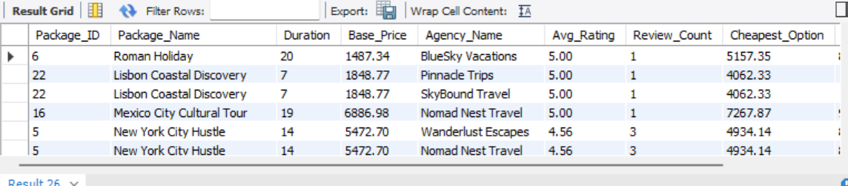
SELECT
p.Package_ID,
p.Name AS Package_Name,
p.Duration,
p.Base_Price,
a.Company_Name AS Agency_Name,
ROUND(AVG(f.Rating), 2) AS Avg_Rating,
COUNT(DISTINCT f.Feedback_ID) AS Review_Count,
MIN(po.Final_Price) AS Cheapest_Option,
COUNT(DISTINCT poe.Experience_ID) AS Experience_Count
FROM PACKAGE p
JOIN AGENCY_DESIGNS_PACKAGE adp ON p.Package_ID = adp.Package_ID
JOIN AGENCY a ON adp.Agency_ID = a.Agency_ID
JOIN PACKAGE_OPTION po ON p.Package_ID = po.Package_ID
LEFT JOIN FEEDBACK f ON f.Package_ID = p.Package_ID
AND f.Package_Type = po.Package_Type
LEFT JOIN PACKAGE_OPTION_EXPERIENCE poe
ON poe.Package_ID = po.Package_ID
AND poe.Package_Type = po.Package_Type
WHERE p.Package_Status = 'active'
GROUP BY p.Package_ID, p.Name, p.Duration, p.Base_Price, a.Company_Name
ORDER BY Avg_Rating DESC, p.Base_Price ASC;
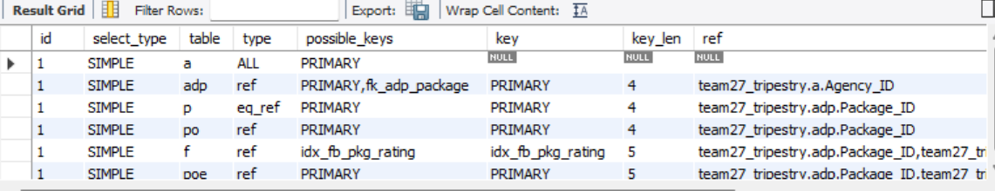
KEY PROBLEMS IDENTIFIED:
1. PACKAGE (type=ALL), full table scan; no index on Package_Status
2. FEEDBACK (type=ALL), full table scan; no index on (Package_ID, Package_Type)
3. PACKAGE_OPTION_EXPERIENCE (type=ALL), full table scan; no index on (Package_ID, Package_Type)
4. Using temporary + Using filesort on PACKAGE — expensive sort with no covering index. With large datasets (thousands of packages, millions of feedback rows) these full scans cause the query to degrade to O(n^4) in the worst case.
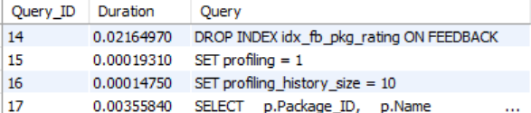
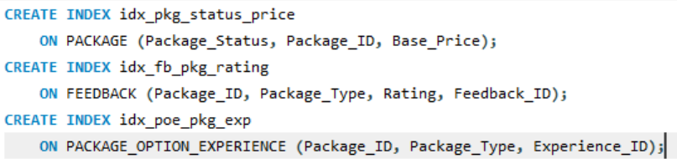
Query after optimization:
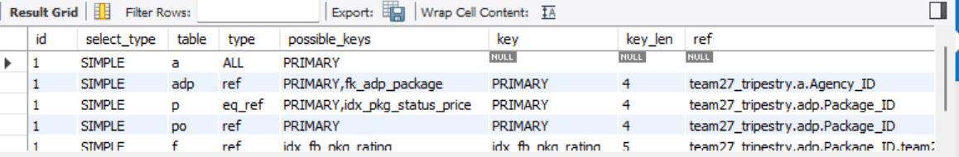
The time taken to run the query went from 0.004s to 0.003s (25% improvement)

